

Skyline Strategy Project

By:

Megan O'Brien
Tanvi Murumkar
Truong Hien Vy Cai
TsuWei Shih

Robert H. Smith School of Business, University of Maryland
BUDT 758J: Enterprise Cloud Computing and Big Data

Section 1
The decision maker for our project is Southwest Airlines, one of the leading domestic carriers in the United States. This project addresses a critical question for Southwest’s strategic planning team: How does Southwest's pricing and performance compare to competing airlines within the top 3 airport groups and are there underserved or overpriced markets across different population and income segments?
As the airline industry becomes increasingly data-driven, understanding competitive positioning is essential—not just to maintain profitability, but also to ensure accessibility and strategic market coverage. To this end, our project aims to evaluate:
- Quarterly fare trends within the top three airport groups by volume, to uncover patterns in pricing behavior and competitiveness.
- Whether Southwest is being 'priced out' in certain geographic or demographic markets, particularly in areas with smaller populations or lower household incomes.
This analysis will help Southwest make informed decisions on where to compete more aggressively, how to align fare structures with local demographics, and how to improve its competitive edge in both high-income urban centers and more price-sensitive regions. The project ultimately supports Southwest’s mission to offer affordable travel without compromising profitability or market share.

Section 2
Data Sources and Techniques
Our analysis integrates multiple structured datasets from official public sources to evaluate fare trends and market behavior across Southwest Airlines routes. Below is a summary of the data sources used:
Dataset | Rows | Key Columns | Source
Fare Data | ~62M | mktfare, mktdistance, originairportid, destairportid, passengers, quarter, year | BTS TranStats
Population | 1,120 | Geography, Geographic Area Name, DP05_0001E → Total Population | data.census.gov
Income | 1,120 | Geography, Geographic Area Name, S1902_C01_001E → Median Household Income | data.census.gov
Airports | 82,895 | local_code, latitude_deg, longitude_deg, iso_country | ourairports.com
Carriers | 1,843 | code, description | BTS TranStats

Data Characteristics and Summary:
Each fare record represents a market segment for a given quarter. We observed 62M+ entries across eight quarterly fare files (2023–2024). Key metrics include an average fare of ~$337, average market distance ~1,636 miles, and standard deviation in fares ranging from ~230 to 1,200, indicating strong variance. For demographic context, population and income data were mapped to airport locations using Census GEOIDs.
Data Cleaning & Aggregation Strategy:
- Fare data were concatenated and grouped by origin-destination airport pairs and time period to compute mean fares, distances, and volumes.
- Airport data were filtered to retain only U.S.-based commercial airports with valid 3-letter IATA codes.
- Census data were cleaned (renamed columns, ensured numeric formats) and merged by extracting and matching the 3-digit GEOID from the Geography field.
- All datasets were merged using consistent keys (airportid, local_code, GEOID, airline code) to form a unified analysis table.
Validation and Quality Checks:
- Join accuracy was confirmed by cross-checking airport codes with city/CSA names.
- Fare distributions were validated by comparing mean vs. median values to account for skewness.
- Flight volume and fare trends were sanity-checked against expected seasonal patterns across 2023–2024.

Analytical Techniques and Tools:
We used Python (Pandas, NumPy, Matplotlib, statsmodels, seaborn, sklearn.metrics) for data cleaning, transformation, and exploratory analysis. The techniques that we used ranged from data joins and aggregation across multiple sources, time series based grouping, handling missing values along with understanding summary statistics & market segmentation using airport groups. We then aimed to perform a comparative analysis of Southwest Airlines across its competitors in addition to modelling techniques like regression analysis, decision trees and random forests to understand fare prices based on demographic and route-specific variables.

Section 3
This section highlights fare trends for Southwest Airlines compared to key competitors across U.S. markets. We examine seasonal patterns, route-level variations, and pricing strategies using visualizations. An explanatory regression model is also presented to identify key drivers of fare prices, including distance, income, and population. We used explanatory regression models, decision trees and random forests to understand the key factors influencing market fare. Of this, the OLS Regression proved most significant, as explained below :

OLS Regression Summary
We used OLS regression to identify key factors influencing log-transformed market fare (log_mktfare) across 649,903 observations. The model explains 8.1% of the variation (R² = 0.081), which is reasonable given the complexity and scale of airfare data.
Key Insights
- Distance (mktdistancegroup): Longer flight distances are consistently associated with higher fares, confirming distance as a strong pricing factor.
- Bulk Fare (log_bulkfare): A significant negative relationship (coef = -6.78) suggests that as discounted or bulk ticket pricing rises, average market fare drops—possibly due to competitive pricing pressures.
- Passenger Volume (log_passengers): Higher demand correlates with higher fares, indicating limited price elasticity or capacity constraints.
- Low-Cost Carriers: Airlines like Allegiant, Avelo, and Spirit show significantly lower fares, confirming their price-disruptive impact in the market.
- Seasonality: Fares peak in Q2 and dip in Q3/Q4, aligning with vacation travel trends and year-end discounts.
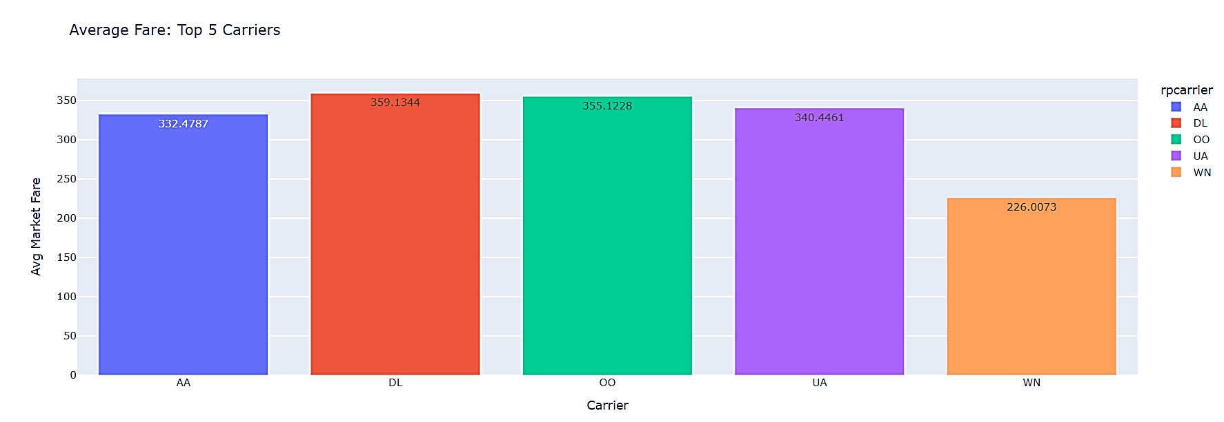
In addition to explanatory regressions, we created visualisations aimed to understand how Southwest Airlines stood against its competitors as shown below :

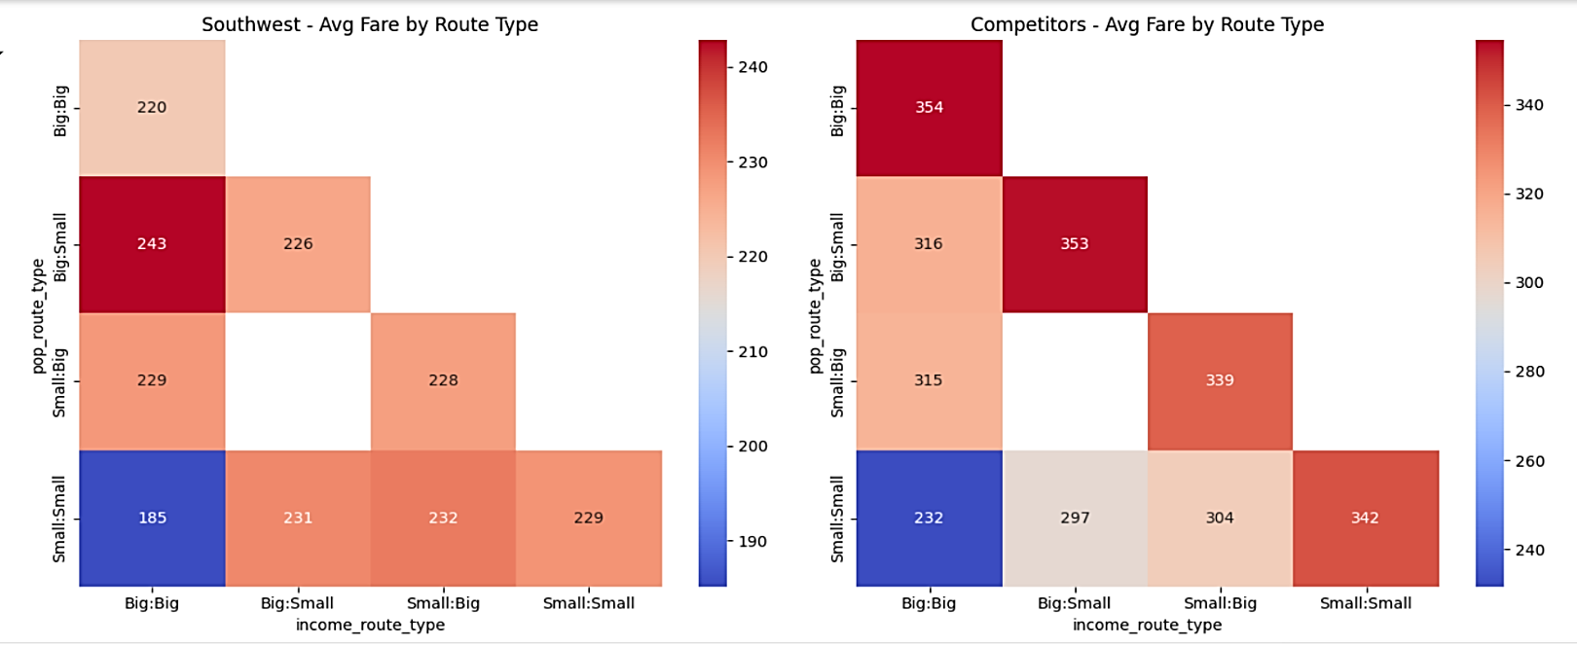
Southwest's average fare ($226) sits significantly below all competitors, undercutting major carriers like Delta ($359), United ($340), and American ($332) by roughly one-third. This dramatic pricing gap highlights Southwest's continued commitment to its low-fare business model in the market.
Additionally, the heatmap above shows the comparison between pricing strategies and their correlations across incomes and population on various routes. Southwest clearly maintains a significant price advantage over competitors across all route types. The most dramatic difference appears in the Big-to-Big market segment where Southwest's average fare ($220) is a whopping $134 less than competitors ($354). Similarly substantial gaps exist in every route category, with Southwest consistently pricing 25-30% lower. Southwest's pricing is most competitive on Small-to-Small routes ($185 vs competitors' $232), suggesting they're particularly focused on maintaining affordability in smaller markets where price sensitivity may be higher.

Section 4

Our analysis confirms that Southwest Airlines maintains a strong competitive advantage through its consistently low pricing strategy across all market segments. Using regression models and machine learning techniques such as Decision Tree and Random Forest, we found that fare levels are most significantly influenced by route type, distance, and carrier, while demographic variables like income and population had less predictive power. Visualizations showed that Southwest’s average fare ($226) is roughly one-third lower than those of major competitors like Delta ($359), United ($340), and American ($332). Heatmaps and comparative graphs further demonstrated that Southwest maintains price stability across different income and population levels, unlike its competitors whose fares fluctuate more dramatically. This strategy is especially distinct in the Small-to-Small market segment, where affordability may be more critical. These findings suggest that Southwest’s low-fare model is not only intact but also strategically deployed across various route types, supporting its brand promise and potentially boosting customer loyalty in price-sensitive markets. Decision makers can leverage these insights to prioritize high-impact routes where the fare differential is greatest, continue investing in price competitiveness, and identify regions where stable pricing offers a strategic edge. For more robust conclusions, future work should incorporate additional years of data, more recent fare trends, and high-volume routes to capture evolving market dynamics. This expanded analysis could also account for external cost factors and allow for more granular pricing strategy recommendations.

Appendix

More Insights into Data Preparation and Joining

For the fare dataset, we aggregated each quarter by airport group and airline and got the mean of all numeric columns. This got rid of the non-numeric columns, like airport code. We needed airport code for getting the Combined Statistical Areas (CSA), so we used the airport group that we grouped by and re-added columns for origin and destination by selecting the first and last three characters of each airport group row. We had to do this for each quarter (8 times) and then concatenated the datasets. This effectively also grouped by year and quarter as we did these steps for each quarter.

The airport data was geocoded using latitude and longitude of each airport code that was located in the US and only had three alphabet characters. This filtered out the helicopter pads, private airports and other countries. CSA was chosen as the degree of census data to focus on so that we could have a broader idea of population and income levels for who the airport services outside of the direct city it’s located in. We merged the geocoded airport data with the concatenated fare data.

The census data (population and income) were joined on the ‘Geography’ column using the merge function. For the joined census data, the GEOID affiliated with the CSA were the last three digits of the ‘Geography’ column. To make this more accessible, we created a new column called ‘GEOID’ which had these codes.

Finally, we merged the geocoded fare data with the joined census data on GEOID. This had to be done twice, one time for origin airports and one time for destination airports. To make the airline names meaningful, we merged the carriers dataset so that we could get the full name instead of the two letter code.

Downloaded the data

For each of the data sets above, the link should bring up the websites for each data set, but there were some special things done for some.
- Fare: we used 8 quarters, but we are only attaching the link for 2024 Q1. To change year and quarter there is a drop down. It shouldn’t matter which boxes are selected for download, but we did select ‘pre-zipped file’ because it was taking too long to download if we didn’t do this.
- Carrier: this link should be the same as the fare dataset, but to get this table we scrolled down to ‘RPCarrier’ and selected ‘Get Lookup Table’.

Southwest Routes by Income Route Type
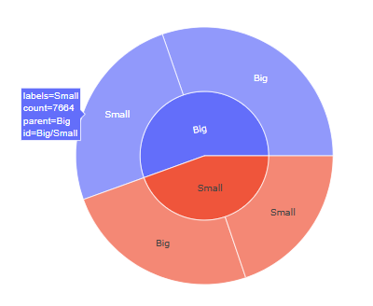
Running of Codes
When running the 4 different .ipynb files, the order does not matter except for ‘final_project_Joining’ would need to be first, if collecting and merging datasets all from scratch. The merged fare dataset will be posted below, which was used for the rest of the .ipynb files.

Final Merged Fare Dataset:
Dataset

